**AI DRIVING CLASSIFICATION**

An LSTM-Based Approach for Driving Behavior Classification

Alberto Pingo   
Department of Computer Engineering  
Polytechnic Institute of LeiriaLeiria, Portugal  
2202145@my.ipleiria.pt

João Castro  
Department of Computer Engineering  
Polytechnic Institute of LeiriaLeiria, Portugal  
2201781@my.ipleiria.pt

*The aim of this project is to explore, analyze and classify driving behaviors using recurrent neural networks. By collecting data from a mobile application, this study seeks to identify driving patterns and train a Long Short-Term Memory model to provide a precising and reliable classification for driving patterns.*

Keywords: Artificial Intelligence, Neural Networks, LSTM, RNN, Driving Classification

# Introduction

Artificial intelligence has caused several industries to change or evolve for the better, and the automotive sector is no exception where the classification of different driving behaviors has become prominent in developing road safety.

The "AI Driving Classification" project aims to harness the power of neural networks to analyze and classify driving behavior. Knowledge of driving behavior is cardinal in improving road safety and developing more Advance Driver-Assistance System and autonomous vehicles. This project recognizes and classifies the driving behavior concerning acceleration, breaking, and driving style by using data off a mobile application.

The importance of driving behavior classification is growing not only within the automotive sector but also within such sectors as transport and logistics, where insight into this behavior would mean better fleet flow, reduced fuel consumption, and general operational efficiency. Detailed driving behavior analysis can also be very useful in aspects related to urban planning and public safety by providing information for better traffic management and road design based on real driving patterns.

Our implementation focuses on not just collecting sensor data from a smartphone but also processing the data in classifying driving behaviors. In our approach, a smartphone has been used because most of today's phones come with state-of-the-art sensor hardware: just an accelerometer, gyroscope, and GPS. We have done rigorous processing on the collected data to get the best possible results for our model. This includes segregating data with respect to the types of maneuvers, after which normalisation and labeling of the dataset are done. All these preprocessing techniques enable one to get the most informative features while reducing noise, which would impair high accuracy for the classification model. We will set up different bases using the processed data on this type of recurrent neural network architecture: the Long Short-Term Memory. LSTMs are applicable in this task since they help in capturing intrinsic dependencies and correlations in time-series data acquired during real driving sessions.

By this, we would be able to classify different driving behaviors, either normal driving or an aggressive one.

Otherwise, our key aim is to get hold of the best LSTM that is to be vigorously trained so as to ensure a very accurate classification of driving patterns.

# Related Work

Several architectures have been proposed and evaluated for their effectiveness in driving behavior classification. Previous studies have recognized that LSTMs perform very well in various sequence prediction tasks. In driving behavior, such models have been able to achieve high accuracy, precision, and recall classifying various driving behaviors. For instance, Huang et al. adopted a fused scheme of LSTMs and CNNs to classify driving behavior in real time, with high accuracy in identifying aggressive and normal behaviors. Zhou et al. investigated the application of LSTMs in predicting the next action that a driver could make, given a series of historical driving data, effectively forecasting the next maneuvers of lane changes or sudden stops.

# Proposed Methodology

## Problem Statement

Fast development in ITS and C-ITS has made it possible to integrate wireless communications between a vehicle and other vehicles (V2) and between vehicles and infrastructures, (V2I). This will enable the sharing of very vital information that shall enhance the management of traffic, its safety, and efficiency. Key challenges that remain for these improvements are requisite with an accurate classification of driver behavior, which shall be critical for developing adaptive and responsive ITS solutions.

The challenge to be addressed in this paper is how to classify driver behaviors only using artificial intelligence techniques with data sourced from a mobile application. Precisely, the focus will be on the training of a neural network model especially the Long Short-Term Memory kind of networks for the analysis and classification of driving patterns. This task, however, is quite well-suited to LSTM networks due to their ability to learn temporal dependencies and sequential patterns of data, which are inherently found in driving behaviors.

This project is focused on the development of a driver classification algorithm that makes use of a resilient LSTM model in order to predict the drivers' behavior for ITS. It thus has huge potential for improving strategies that govern traffic management, lowering accident rates, and ensuring overall safer and more efficient systems of transportation.

## Driving classification based on Long Short-Term Memory

Long Short-Term Memory is an improved version of the recurrent neural network (RNN) designed by Hochreiter & Schmidhuber [2]. LSTM is well suited for sequence prediction tasks and excels at capturing long-term dependencies.

A traditional RNN has a single hidden state that is transmitted over time, which can make it difficult for the network to learn long-term dependencies. LSTMs solve this problem by introducing a memory cell, which is a container that can store information for an extended period of time [5] . LSTM networks are capable of learning long-term dependencies in sequential data, which makes them suitable for tasks such as language translation, speech recognition, and time series prediction [5]. LSTMs can also be used in combination with other neural network architectures such as Convolutional Neural Networks (CNNs) for image and video analysis [5].

Figure 1 - Diagram of an LSTM cell

An LSTM includes a series of memory cells, blocks responsible for storing and processing information over time. Every LSTM cell holds three gates: the Input Gate, the Forget Gate, and the Output Gate.

### Input Gate Equation

*ft = ( W*f *[*ht-1, xt*] +* bf *)*

### Forget Gate Equation

it *= ( W*i *[*ht-1, xt*] +* bi *)*

ĉt *=* tanh *( W*c *[*ht-1, xt*] +* bc *)*

### Output Gate Equation

ot *= ( W*o *[*ht-1, xt*] +* bo *)*

## Long Short-Term Memory Networks Combined with Convolutional Neural Networks

Convolutional Neural Networks, particularly Conv1D, are computationally less demanding, and thus faster to train and run in comparison with traditional LSTMs, especially using Conv1D.

Such architecture is very proficient in extracting relevant patterns from subsequences, which has a positive impact on the results obtained. Because CNN provides the opportunity to apply pooling layers, the dimensions of data are reduced, and this reduction reduces model complexity, helps avoid probable overfitting. However, the major benefit in usage that stands out would be this architecture's ability to combine with others, such as LSTMs, in improving results and helping with scalability.

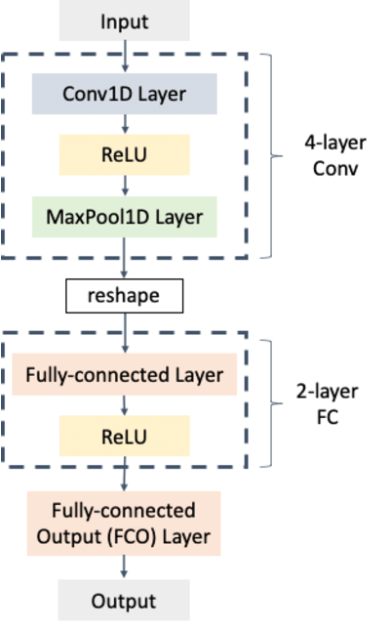

Figure 2 - Diagram of a 1D CNN Implementation using Max Pooling

The effectiveness of 1D Conv depends mainly on the input data structure since in cases where the data does not have a clear temporal pattern or sequences, 1D Conv will not produce accurate results.

## Data Processing

The data processing consisted of the identification and categorization of different driving maneuvers:

* Sudden acceleration and deceleration
* Turns and lane changes
* Abrupt stops and start

This was performed by the use of six sensors detecting both the accelerometers and gyroscopes along the axes of X, Y, and Z. In general, accelerometers detected linear acceleration, gyroscopes detected angular velocity, and the measurement was taken along the same axes.

After data collection, a preprocessing step was applied to separate positive and negative values. This was to allow the model to have a maximum probability of not being affected by potentially negative numbers. As a result, two columns were created: one containing only positive values and another containing only negative values collected by the respective sensors.

Subsequently, these two columns were organized into a 2D array consisting of a total of 12 elements: 6 positive and 6 corresponding negative elements derived from the processed sensor data.

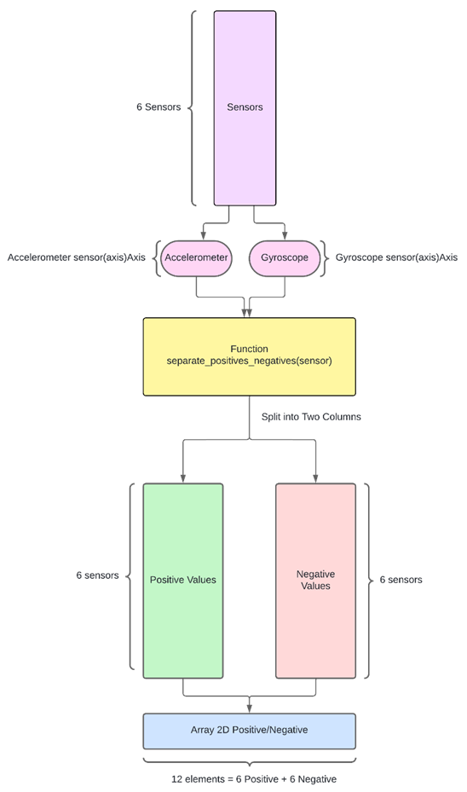

Figure 3 - Diagram of the Data Processing Process

## Data Classification

The process starts by inputting two parameters into the function **y_classification(data, threshold)**: data and threshold. The intention of the **y_classification** function is to return a Boolean value classifying the data in relation to **1**, meaning aggressive behavior, and **0** for non-aggressive behavior. It initializes an **output_vector** that will hold these classifications.

This will involve looping through all columns of the dataset—all 12—and compute the maximum value of each column, done using the numpy function **np.max(data[:,col])**. After getting the maximum value of every column, **threshold_pos** was computed by multiplying this maximum value by a threshold parameter passed as input to **max_value** * **threshold**.

The classification of the data is then carried out as follows:

* If the data value is greater than or equal to the **threshold_pos**, it is classified as 1 (**aggressive**).
* If the data value is less than **threshold_pos**, it is classified as 0 (**non-aggressive**).

Finally, the vector, initialized with the result of the classification, is returned with this data classified.

Figure 4 - Diagram of the Data Classification Process

## Data Normalization

The data was normalized to compare the different data types and also for improving the performance of the model. This normalization involved:

Scaling: This is the adjustment of the values of each variable to some common range, say **[0, Max Value of each Sensor Set]**.

The data normalization process starts with the application of the **'max_of_vectors'** function, which can have two variations:

* For the case of an accelerometer device, where among others, the input parameters are: **‘turnRightX’,‘turnLeftX’,‘accelY’,‘breakY’, ‘positiveZ’, ‘negativeZ’**
* For the gyroscope, where the input parameters are**:‘gyrPositiveX’,‘gyrNegativeX’,’gyrPositiveY’,’gyrNegativeY’,’gyrPositiveZ’,’gyrNegativeZ’**

This function concatenates all columns of input into one vector and returns the maximum value of this vector.

Figure 5 - Diagram of the Max Of Vectors Function Applied to the Accelerometer

Figure 6 - Diagram of the Max Of Vectors Function Applied to the Gyroscope

The result will be the maximum value of the accelerometer that is applied to normalize function as the input parameter.

Figure 7 - Diagram of the Data Normalization Process

## Split Data into Training and Test Sets

The model is tested on part of the data divided for training and testing. This was done in a ratio as follows:

* 80%: Training Data
* 20%: Testing Data

The process of dividing the data into training and testing sets used the function **split_train_test(data, test_size=0.2)**. The input parameters to the function are the data and the size of the test data sequence. The size parameter impacts directly on the size of the training sequence.

Specifically, **test_size = 0.2** means **20%** of the data will be used for testing the model, while the remaining **80%** stays in the train sequence. This is an equal and fair split to both so that training can be effectively done based on it and performance evaluation can also be reliable.

Figure 8 - Diagram of the Data Separation Process

## Data Representation

To a better analyze of the recorder maneuvers, we use the Folium Library to create an interactive map. A marker cluster was added to the map to visually group nearby event.

Markers were then added for each recorder position, differentiated by colors to represent different type of maneuvers.

Figure 9 - Plot of Dataset Maneuvers

Figure 10 - Plot of Zoomed Dataset Maneuvers

## Model Construction

The model adopted in the present study is a hybrid architecture that presents both convolutional neural networks with one dimension (Conv1D) and long short-term memory networks, which is designed for the classifier of driving behaviors based on sensor data. Its model architecture is described below:

### Model architecture

#### Conv1D Layer

* Filters: 64
* Kernel Size: 1
* Activation: ReLU
* Input Shape: (number of time steps, number of features)

Where Conv1D is the convolutional layer that helps to extract local features from time-series input data, using 64 such filters of size 1 captures fine-grained patterns in this data.

#### Batch Normalization :

This layer helps to normalize the output of the Conv1D layer in order to increase training stability and speed.

#### Dropout Layer:

* Dropout Rate: 0.5

Dropout is there to prevent overfitting, as it randomly sets half of the Conv1D layer output units to zero during training.

#### Primary LSTM Layer:

* Units: 256
* Return Sequences: True

The first LSTM layer captures the temporal dependencies within the data and returns sequences for processing by the next LSTM layer.

#### Dropout Layer

* Dropout Rate: 0.2

For the prevention of overfitting, dropout is applied on the output of the first LSTM layer.

#### LSTM Layer (Middle):

* Units: 128

The second layer of the LSTM network further deals with the temporal dependencies existing in data, reducing the output to a fixed-size vector.

#### Dropout Layer:

* Dropout Rate: 0.2

To prevent overfitting, the output of the second LSTM layer is passed to a Dropout layer.

#### Dense Layer:

* Units: 12
* Activation: Sigmoid

The Dense layer using 12 units and the activation function sigmoid give the final classification scores for each class.

Model Compilation The model is built using the following parameters:

* Optimizer: Adam
* Loss function: Binary Crossentropy
* Metrics: Mean Absolute Error (MAE)

The Adam optimizer employs high-level adaptive learning rates and demonstrates efficiency, which may alleviate the typical problems of training deep neural networks [1]. The binary crossentropy loss is selected as the criteria based on which the structure is optimized, and the model is evaluated through validation using MAE. This makes the hybrid Conv1D-LSTM model able to extract the strengths of these convolutional and recurrent layers to derive spatial and temporal features from sensor data, making it good at performance in driving behavior classification.

# Experiments

In our experiments we focus on comparing several advanced models, including Stacked LSTM, ConvLSTM, and BiLSTM. The selection of the models used in this research study has been based on the effectiveness associated with handling temporal and spatial dependencies.

The dataset used for training and testing the models comprises a rich collection of driving behavior data, including sequences of sensor readings.

## DataSet

The dataset used in this project is designed to record all types of sensor data from mobile devices. It comprises several contents and supports many formats and versatile data handling and analysis.

### CSV Structure

#### Label

* Name identifier for the dataset.

#### CreatedAt

* The exact time and date that the dataset was created.

#### CaptureSpeed

* Data capture frequency in milliseconds.

#### GravityFilter

* An option to, if on, remove gravitational effect from accelerometer values.

#### AverageFilter

* Smoothes sensor values.

#### ElapseTimeInSeconds

* Duration in seconds when data has been captured.

#### Device Information

* AndroidID
  + A Unique Identifier for the device.
* Name
  + User-defined device name.
* Manufacturer
  + Device brand name.
* Brand
  + Brand of the device.
* Model
  + Device model.
* Accelerometer
  + Includes maximum range, sensor name, minimum delay, and readings on X, Y, and Z axes.
* Gyroscope
  + Includes maximum range, sensor name, minimum delay, and readings on X, Y, and Z axes.
* Location Data
  + Latitude, longitude, and speed in km/h.

#### Timestamp

* The date and time for every entry of data.

## Training

Selection of Mean Absolute Error MAE as the primary metric for our Long Short-Term Memory LSTM model evaluation is driven by several key considerations in a manner quite consistent with the nature of our driving behavior classification problem and the characteristics of LSTM networks.

First, the simplicity and interpretability of MAE make it an excellent choice for understanding how a model's performance would be. It reflects the average magnitude of errors between estimates and true values, showing how well a model can predict driving behaviors. This simplicity will be important in results communications to non-technical audience members, most especially stakeholders who wouldn't have a clear understanding of some other evaluation complex metrics. Another advantage of MAE over driving behavior data is its robustness to outliers. Driving behavior datasets often contain rare or extreme events. If mean squared error metrics are used, these events will distort the results since MSE squares the errors, thus giving a disproportionate weight to outliers.

On the other hand, MAE treats all errors equally and hence gives a balanced measure of overall model performance, not skewed by these rare events.

The training of the Conv1D-LSTM model was further augmented by deploying callbacks to provide the best model performance and to protect against overfitting.

With the *ModelCheckpoint* callback, each training epoch

if the val_loss was lower than the previous epoch, the model saved as the best model. In this way, only the model having the lowest validation loss will be used for a final evaluation and deployment.

We also use an early stopping callback, which paused the training process when validation loss did not improve for several epochs. This method avoided overfitting and saved some extra time for training.

The model was trained using the fit method passing in the training (train and y_train) and validates it with validation (test and y_test). This was set up to run for 30 epochs while running a batch size of 256, though, technically, this could stop earlier due to the early stopping callback.

## Performance Evaluation

Figure 11 - Mae and Val_Mae Throughout the Epochs

As shown in Figure 1, the MAE and validation MAE during training converged within 30 epochs. From this plot, it is clear that both training MAE and validation MAE drop sharply in the early epochs before stabilizing. This basically means that most models learn well with respect to the data presented to them for training and generalize quite well on their validation sets as well.

Figure 12 - Model Performance Graph

This plot in Figure 12 represents part of the test data predicted by the model against true values, in order to show how close the models predictions were to the real values and which models differed.

## Results Comparison

Evaluation of the implemented models was supported by several metrics and visualizations. Hence, the major aspects of their evaluation include MAE over training epochs, with other relevant metrics such as accuracy, precision, recall, F1 score, Hamming loss, Jaccard score, and label ranking loss.

Table 1 - Metrics Comparison Between Models

| Metrics | Models | | |
| --- | --- | --- | --- |
| Proposed ConvLSTM | BiLSTM | Stacked LSTM |
| Accuracy | 97.71% | 96.06% | 96.38% |
| Precision | 95.40% | 84.66% | 95.00% |
| Recall | 93.02% | 87.56% | 85.65% |
| F1 Score | 93.96% | 81.66% | 89.29% |
| Hamming Loss | 0.20% | 0.33% | 0.32% |
| Jaccard Score | 88.95% | 72.69% | 81.95% |
| Label Ranking Loss | 0.91% | 0.36% | 2.23% |

In the Table 1, can compare the different results of the metrics for the models built. As we can observe, all models exhibit high accuracy, with the proposed model reaching an accuracy rate of 97.71%.This demonstrates that in most instances, the models are able to correctly classify a driving behavior. The precision and recall values are also high, with Proposed ConvLSTM and Stacked LSTM particularly strong performance, suggesting that these models are effective in identifying relevant driving behaviors without many false positives or negatives. Definitely, the balanced performance of the models, with the present proposal ConvLSTM, can be confirmed with this F1 score, which is found as a harmonic mean of Precision and Recall, leading at 93.96%.

The low values that Hamming loss acquires are a few fractions of incorrectly predicted labels. Proposed ConvLSTM has as low as 0.20% of Hamming loss.

High Jaccard scores indicate that the model has strong overlap between the predicted and real driving behaviors, where Proposed ConvLSTM leads again at 88.95%. Low label-ranking losses in BiLSTM indicate that the true labels are ranking highly among the predicted labels, even though it had lower performance metrics compared to Proposed ConvLSTM and Stacked LSTM. Overall, the best performance with respect to most of the metrics in this study is the proposed model, ConvLSTM, which can be interpreted as fairly superior with due respect to capturing and predicting driving behaviors accurately.

# Conclusion

In this work, we developed and compared three LSTM-based models for driving classification problem: Stacked LSTM, ConvLSTM, and Bidirectional LSTM. This study is carried out to find the efficiency of each architecture in capturing temporal dynamics from driving data and their robustness across different driving conditions.

Very importantly, our experiments have shown that each model has its strengths. The Stacked LSTM model had high learning capacity for complex temporal patterns due to the presence of multiple layers of LSTMs, thus performing well in tasks involving intricate sequential dependencies. Then, using convolutional layers, the ConvLSTM model was able to capture features in both the spatial and time domains, outperforming others in scenarios that required detailed analysis in the space-time dimension.

The Bidirectional LSTM performed very well at understanding context from both past and future sequences and turned in superior performance in tasks that require comprehensive sequence context.

In this project, we have contrasted these LSTM architectures with respect to their peculiar advantages and limitations in the context of autonomous driving. We embedded domain adaptation techniques into our models, thereby solving a big gap found in the previous literature, which more importantly enhanced their performance on different driving conditions. More importantly, enhanced attention mechanisms ensure AI-driven decisions are made transparently and become more understandable.

Although the models were extremely promising, there are a number of topics that clearly open up avenues for further investigation. Future research shall be focused on optimization of these models for real-time applications, where scalability remains challenging. Expanding training datasets to hold more varied driving environments will increase model robustness. Further development of methods for interpretability is also required to make AI systems able to provide clear and human-understandable explanations for their decisions.

##### Acknowledgment

This work was supported by the Polytechnic Institute of Leiria. We express our gratitude to the institution for its invaluable support and resources, which were crucial to the successful completion of this project.

##### Acronyms

AI: Artificial Intelligence

CNN: Convolutional Neural Network

C-ITS: Cooperative Intelligent Transportation Systems

GPS: Global Positioning System

ITS: Intelligent Transportation Systems

LSTM: Long Short-Term Memory

MAE: Mean Absolute Error

MSE: Mean Squared Error

RNN: Recurrent Neural Network

V2I: Vehicle-to-Infrastructure

V2V: Vehicle-to-Vehicle

##### References

1. D. P. Kingma and J. Ba, “Adam: A Method for Stochastic Optimization,” arXiv preprint arXiv:1412.6980, 2014.
2. LSTM Full Form - Long Short-Term Memory - GeeksforGeeks. (n.d.). Retrieved July 17, 2024, from <https://www.geeksforgeeks.org/lstm-full-form-long-short-term-memory/>
3. S. Bouhsissin, N. Sael and F. Benabbou, "Driver Behavior Classification: A Systematic Literature Review," in IEEE Access, vol. 11, pp. 14128-14153, 2023.
4. K. Saleh, M. Hossny and S. Nahavandi, "Driving behavior classification based on sensor data fusion using LSTM recurrent neural networks," 2017 IEEE 20th International Conference on Intelligent Transportation Systems (ITSC), Yokohama, Japan, 2017, pp. 1-6
5. What is LSTM - Long Short Term Memory? - GeeksforGeeks. (n.d.). Retrieved July 17, 2024, from https://www.geeksforgeeks.org/deep-learning-introduction-to-long-short-term-memory/